Abstract
This Project Focuses With “TVETI” inventory management System is Designed to Properly Maintain Properties of the INSTITUTE and Distribute them Appropriately to the Employees as per their Requirement and Approval of their User. Web Based Inventory Management System Mainly Provides Effective and Fast Data Processing and Controlling of Stocks. The System Performs item Registration, Supply Registration, Manage Notice, Bids, Send Item Request and Approve item Request. The Project is Implemented in PHP, Html, Css and MySQL Server Database. Object Modeling Tools like UML are Also used.
Content Page No
Abstract --------------------------------------------------------------------------------- 3
Acknowledgment ------------------------------------------------------------------------- 4
List of Acronym and Abbreviations----------------------------------------------------------7
Chapter One-----------------------------------------------------------------------8
  - Introduction ---------------------------------------------------------------------------8
  - Back Ground of the Project--------------------------------------------------------------9
  - Statement of the Problem---------------------------------------------------------------10
  - Objective of The Project ----------------------------------------------------------------10
1.4.1 General Objective -----------------------------------------------------------------10
1.4.2 Specific Objective -----------------------------------------------------------------10
1.5 Scope of The Project----------------------------------------------------------------11
1.6 Limitation of The Project------------------------------------------------------------11
1.7 Significance of The Project----------------------------------------------------------11
1.8 System Requirement----------------------------------------------------------------11
1.8.1 Hardware tool Required------------------------------------------------------------11
1.8.2 Software Required----------------------------------------------------------------12
1.8.3 Programing Language-------------------------------------------------------------12
1.9 Data Collection Methodology--------------------------------------------------------12
1.10 Feasibility Study of The New System-------------------------------------------------13
1.10.1 Economic Feasibility--------------------------------------------------------------13
1.10.2 Technical Feasibility-------------------------------------------------------------13
1.10.3 Operational Feasibility-----------------------------------------------------------13
1.10.4 Legal Feasibility ---------------------------------------------------------------13
Chapter Two----------------------------------------------------------------------14
2. Over View of The existing system------------------------------------------------------14
2.1 the existing system Performs the following activity in Manually--------------------------14
2.2 Over View of The Proposed System----------------------------------------------------14
2.3 Requirement Specification-----------------------------------------------------------15
2.3.1 Functional Requirement -----------------------------------------------------------15
2.3.2 Non-Functional Requirements-----------------------------------------------------15
2.3.3 Business Rule-------------------------------------------------------------------16
2.4 System Requirement Analysis-----------------------------------------------------16
2.4.1 Actor and Use case Identification--------------------------------------------------16
2.4.2 Actor Identification--------------------------------------------------------------16
2.4.3 Use Case Diagram---------------------------------------------------------------19
2.4.4 Use Case Description------------------------------------------------------------20
2.4.5 Sequence Diagram--------------------------------------------------------------21
2.4.6 Activity Diagram-----------------------------------------------------------------24
2.4.7 Analysis Class Diagram----------------------------------------------------------28
Chapter Three-----------------------------------------------------------------29
3. Conclusion and Recommendation --------------------------------------------------29
3.1 conclusion ----------------------------------------------------------------------29
3.2 Recommendation-----------------------------------------------------------------29
3.3 Future Enhance------------------------------------------------------------------29
Summary ---------------------------------------------------------------------------
Appendix ---------------------------------------------------------------------------
Reference --------------------------------------------------------------------------
Table 1. Use Case Identification--------------------------------------------19
Table 2. Login Case Description-------------------------------------------21
Fig 1. Use Case Diagram----------------------------------------------------------------------20
Fig 2. Sequence Diagram for Login-------------------------------------------------------------22
Fig 3. Sequence for Registration---------------------------------------------------------------22
Fig 4. Sequence for Send Feedback------------------------------------------------------------23
Fig 5. Sequence for View Item-----------------------------------------------------------------23
Fig 6. Activity Diagram for Login---------------------------------------------------------------24
Fig 7. Activity for Send Request----------------------------------------------------------------25
Fig 8. Activity for Register Item----------------------------------------------------------------26
Fig 9. Activity for View Item-------------------------------------------------------------------27
Fig 10. Analysis Class Diagram----------------------------------------------------------------28
List of Acronym and Abbreviations
TVETI----------------------------Technical Vocational and Educational Institute
HTML----------------------------------------------Hyper Text Markup Language
CSS------------------------------------------------------Cascading Style Sheet
PHP---------------------------------------------------Hyper Text Pre Processer
ID---------------------------------------------------------------- Identification
UML--------------------------------------------------Unified Modeling Language
UC-------------------------------------------------------------------Use Case
WAMP---------------------------------------------Windows, Apache, MySQL, PHP
MYSQL--------------------------------------------My Structured Query Language.
PC--------------------------------------------------------Personal Computer
CD---------------------------------------------------------Compact Disc

CHAPTER ONE
- Introduction
The use of technology is increasing day to day, we all depend on technology and we use various technologies to accomplish specific tasks in our lives. Today we have various emerging technologies which impact our lives in different ways. Technology is being implemented in almost every section of our lives and business structures. Some of the uses of technology today are in health, education, government, communication, purchasing, agriculture, control and harness natural forces, transportation, bank etc. More specifically Technology has a bigger impact on inventory control in terms of efficiency, ease of accessing information and accuracy there by affecting organization performance, centrally manage all store inventory management and improve availability of the system.
An inventory is the stock of items used in an organization. An inventory system monitors the levels of inventory and determines the recording of items and distributing the materials to the staff based on the request of users. But, Currently TVETI property administration directorate performs recording items, managing, requesting materials, register supplier through manually this leads to time consuming, error prone and boring. In order to solve this problem, the team motivated to develop a web based inventory management system.

1.2 Background of the Project
TVETI was established in 2003 E.C. Now it has One Main Campus here in Addis Abeba and Fifteen Satellite Campus in different Regions of the Countries. The main campus which is found in Addis Abeba on Yeka sub city Around Lambaret Section. and it has Four Faculty. Those are faculty of Civil Technology, Mechanical Technology, ICT & Electrical Electronics Technology and Textile and Apparel Fashion Technology within Sixteen Department. TVETI property administrator office is started when the university was established. Property administrator office is centrally maintained in the Office of property administrator directorate. The Office of property administrator directorate currently works register supplier, register items, register item withdraw, transfer item, and generate report like withdraw, received and damage items. Property administrator office deals primarily with determining the amount and placement of the materials within a facility or within multiple locations of a store. One way of managing this system is to have a web-based system in place that can instantly track and update the information about the tools or equipment. The importance of implementing a web based inventory system is becoming vital as most of the time the information are accessible directly, so making the details of the usage of the equipment available, and improving the movement and anticipation of their demand as well as the productivity of the system as a whole. register supplier, register items, register item withdraw, transfer item, and generate report like withdraw, received and damage items. Property administrator office deals primarily with determining the amount and placement of the materials within a facility or within multiple locations of a store. One way of managing this system is to have a web-based system in place that can instantly track and update the information about the tools or equipment. The importance of implementing a web based inventory system is becoming vital as most of the time the information are accessible directly, so making the details of the usage of the equipment available, and improving the movement and anticipation of their demand as well as the productivity of the system as a whole.

1.3 Statement of the Problem
The existing property administrator directorate in TVETI is currently done through manually so, it
has the following problem.
- Difficult for university department head and office head to know list of items used by his staff.
- Difficult for property administration teams to know list of items a specific employee used.
- When errors are made by employees of the store at any point of their work during register the item.
- Difficult for property administration teams to know where the specific item is found
- Difficult for property administration teams to know list of items a specific department and office.
- Difficult to generate a report like received, withdraw items because it requires more effort and time consuming to recover and check the registered item.
- Difficult to approve clearance because not get easily employee information
- In transfer of item problem is exist, because the signature of employee is put in paper so, the paper is may be lost or damage.
- Files put in excel difficult to search specific information about items and employees.
- Data is not secured because any user that have access to that computer can modify the excel files.

1.4 Objective of the Project
1.4.1 General Objective
☞ The general objective of this project is to develop web based inventory management system for TVETI
1.4.2 Specific Objective
- To keep records of new, taken properly.
- To relocate, change the status of items whether issued or not
- To develop secure database that holds information about items and customers.
- To develop system that register items and users.
- To develop system that update items and users.
- To minimize delay of service by providing lists of properties available in the store
1.5 Scope of the Project
☞ The project that we are trying to focus on inventory management system will cover only on the TVETI

1.6 Limitation of the Project
- The system not prepare well organized report
- The system not develops android in a way to support mobile users.
- The system not including other language like Amharic language
- The system not including integrated system like human resource management system
1.7 Significance of the Project
Some of the significances of the system are:
- Easy to know where the materials are found.
- When items are issued to employees the system can automatically update the information an item or change its status
- Better security and management of item file.
- Easy to manage clearance because the record is well organized and can search by its Id and easy to check the materials under on each employee.
- It reduces the probability of errors that will be made during registering the issued, received and remained items to the store.
- It improves item transfer because easily know where specific item is found. i.e. the movement of item from one employee to another is easily updated by the system.
- Proper utilization of inventory resource such as cost, human resource, time etc. can be maintained.
1.8 System Requirement
1.8.1 Hardware Tools Required are:-
- Personal Computer (PC):- almost all tasks of our project are performed on computer.
- Flash Disk: required for data movement and store.
- Disk (CD):-necessary for the store of relevant data and for backup Pen and Paper: used for write different question and resource.
- A4 Paper: used to write necessary data during data gather process.
1.8.2 Software Tools Required are:-
- WAMPSERVER:- to test the system by running.
- MYSQL (My Standard Query Language) (database), for creating and manipulating databases.
- Microsoft Word 2013: to write on any necessary documents about the project.
- Code lobster php edition: to write the code we use this application.
- Microsoft office Visio 2010: used to draw UML diagrams.
1.8.3 Programming Language
The Programming Language the Team Uses are:
- PHP (Hypertext Preprocessor):- Because of we select PHP:-
- Easy to use
- Platform Independent(It can be run on all major operating systems)
- Supports all major Web Servers
- Supports all major Databases
- open source
- Easy to fix problems etc.
- MySQL (My Standard Query Language): - for Creating and Manipulating Databases.
- MySQL database- the project team used MySQL database since
- Easy to use
- Open Source
- It is fast and secure
- runs on many operating system
- Hypertext Markup Language (HTML):- allow for building HTML pages website creation.
- Java script language: - to create interactive Web Pages.
1.9 Data Collection Methodology
- Data collection is the most important part of our project to find the main required information to system and to understand how the system works. We used the following methods to collect relevant data required to our project.
- Interview:- To get information, interview with the store head will be conducted with concerned staff of the corporation to get reliable information which is important to do the project.
- Observation:- It helps us to get the right information how the organization performs its function and this helps to strength the data that gathered through interview and document analysis.
- Document Analysis:- This technique provides information on how the existing system works .There for documents related to the existing system of the organization will be assessed.
  - Feasibility Study of the New System
1.10.1 Economic Feasibility
- An economic feasibility is a process of identifying the financial benefits and costs associated with a development of a project.
- The proposed web based inventory system is economically feasible because:
- The system will provide fast and efficient automated environment.
- This project is economically feasible because its anticipated benefit is greater than the expected cost.
1.10.2 Technical Feasibility
- The proposed system can be easily maintained and repaired technically; the system will be powerful to be applied by low skilled users as much as possible. It is easily accessible by the people who can easily understand natural languages.
1.10.3 Operational Feasibilities
- The system will also be on behalf of origination’s goal and user satisfaction, because the system will be possible to run and use in the organizations LAN internet. So the system will be operationally feasible or it will be operationally acceptable to users in TVETI inventory office.
    - Legal Feasibility
- The project team members built the system without violating rules and regulations of the governments as well as the organization. The system being built is for the importance of productivity of the organization, so that the project is legally feasible. Legal feasibility determines whether the proposed system conflicts with the legal requirement or not.

CHAPTER TWO
2. Over View of the Existing System
The existing system is performed activities from storing material on stoke to deliver the employee. First the store clerk post bids and register the designated supplier, after the designated supplier supply the item, the store head receive material from supplier, checks the incoming item by related professionals. Then the store clerk receives the material from the store head and he/she assigns a code and record the item information. After that the store clerk must get permission to receive and give the materials to the staff members by the head of the store office. Then the store clerk documents the item information and reports those materials detail based on their item type to the store head. And the store clerk gives the material to the employee, department, department head, president, or office based on their request.
  - The Existing System Performs the Following Main Activities in Manually.
- Register Supplier:- register supplier organization to supply item for the organization.
- Register new Items:- the new items are register before enter to the store.
- Register item Withdraws:- the item is register after give to collage, department, employee and office.
- Register Item Transfer Between Two Employees:- during item transfer from one employee to another it must register.
- Approve Clearance:- when an employee is leave out from staff member he/she must fill the clearance form.
- Prepare Report:- like damaged item, new item, withdraw item: reports are prepared based on the category.
2.2 Over View of the Proposed System
- The proposed system will reduces the existing problems which usually occurred in TVETI inventory office. Proposed system is to improve some activities through computerized way that simplifies the workload of the existing system and speedup the operation of the system. The new system performs from send request to deliver item based on request from different department and office. Stock clerk register new, withdraw and transfer item from the beginning to the end. Proposed system is a system which avoids more manual hours that need to spend in record and keeping the data in a centralized way which is available to all the users simultaneously.
- It is very easy to manage historical data in database. No specific training is required for the employees to use this system. They can easily use the system to decreases manual hours spending for normal things and hence increases the performance. Generally the proposed system has advantages by easy to manage all the daily transactions, can generate required reports easily, easy to manage historical data in a secure manner, centralized database helps in avoiding conflicts and easy to use GUI that does not requires specific training.
2.3 Requirement Specification
- System Requirements Specification is requirement by the system to achieve its goal. In this section we have kept the basic understanding of the requirements and dependencies of the current system prior to any actual design or development work. We deal the functional and nonfunctional requirements of the proposed systems.
2.3.1 Functional Requirement
- Functional requirements are the planed behaviors of the system. This behavior may be expressed as services, jobs, utilities or functions that the system is required to perform.

- Since the team are going to develop computerizing inventory management system that used by the employee’s in the university, the system is used to manage and process data according to the System.
☞ The New System is Expected to Provide the Following Functionalities:-
- Register of supplier department and office.
- Registering of the new items based on their category.
- Displaying information about the item.
- Searching for items that are available in the stock.
- Generating and recorded new items.
- Generating withdrawal items in the store.
- Generating received and withdraws item.
2.3.2 Non-Functional Requirements
- Non-functional requirement describes the necessities of the computerized inventory management system that are not directly related to the functionalities of the proposed system and any constraints that may limit the boundaries of the proposed system. In short, non-functional requirement is all about system attributes such as security, reliability, usability, integrity and so on.
- Security:-The system only permits authorized user to enter the system. Authorized users are who have username and password by using encryption technique is called md5 algorithm.
- User Interface:- The interface is user friendly and can properly guide the user how to use the system and perform operations easily.
- Response Time:- the system gives response to service request within a short period of times.
- Availability:- This system should always be available for users to access item information.
2.3.3 Business Rule
- A business rule is an operating principle or policy the software must satisfy. It often concern to access control issues, policies and principles of the inventory management system.
- The existing system has business rules or principles some of them are: only staff members of the university are allowed to take an authenticated material, one employee to fill clearance first checked either any material with him/her or not.
2.4 System Requirement Analysis
2.4.1 Actor and Use Case Identification
- Actors: An actor is a person, organization, or external system that plays a role in one or more interactions with in the system.
- We use Actor as user that interacts with system.
- Use Cases:- A use case describes a sequence of actions that provide something of measurable value to an actor.
2.4.2 Actor Identification
- In inventory management system the following actors are involve: System administer, Director, Department head, Property Administration Directorate , Stock clerk, Employee, Customer, President of The University, Vice President, Academic Dean, Department Head. Procurement commute.

- Customer: have the following activities
        - View bids
        - View notice
- Admin: have the following activities
- Create user account
- View account
- Take Backup
- Restore Data Base
- Director: have the following activities
- View item
- Send item request
- View Response
- Send feedback
- President: have the following activities
- View Response
- View item
- Send item request
- View bids
- Vice President: have the following activities
- View item
- Send item request
- View bids
- Property Administration Director: have the following activities
- view item
- send item request
- View item request response
- View feedback
- Post bid
- Post notice
- Academic dean: have the following activities
- View item to assign college
- Send item request
- Approve request
- Send feedback
- Register allowed employee
- Department head: have the following activities
- View item to assign department
- Send item request
- View response
- Send feedback
- Stock clerk: have the following activities
- Register college
- Register department
- Register employee
- Register office
- Register item
- Register item withdraw
- Register item transfer
- Register supplier
- Register position
- View item
- Update item
- Register item withdraw
- Register item transfer
- Employee: have the following activities
- View item
- Send feedback

Table 1. Use Case Identification

Use case name | Use case ID | Include
Login | Uc1 | Login
View response | Uc2 | Login
View item | Uc3 | Login
Register item transfer | Uc4 | Login
Register item withdraw | Uc5 | Login
Send item request | Uc6 | Login
Register item | Uc7 | Login
View request | Uc8 | Login
Send feedback | Uc9 | Login
View feedback | Uc10 | Login
Take Backup | Uc11 | Login
Approve clearance | Uc12 | Login
Approve request | Uc13 | Login
Register supplier | Uc14 | Login
Create user account | Uc15 | Login
Register collage | Uc17 | Login
Register department | Uc18 | Login
Register office | Uc19 | Login
Post notice | Uc20 | Login
View notice | Uc21
Post bid | Uc22 | Login
View bid | Uc23

2.4.3 Use Case Diagram
- A use case diagram is a collection of actors, use cases, and their communications. A use case diagram is a graphic depiction of the interactions among the elements of a system. A use case is a methodology used in system analysis to identify, clarify and organize system requirements. A Use Case Model describes the proposed functionality of a new system. A Use Case represents a discrete unit of interaction between a user and the system. Use case is a list of steps, typically defining interactions between a role and a system to achieve a goal.(2)

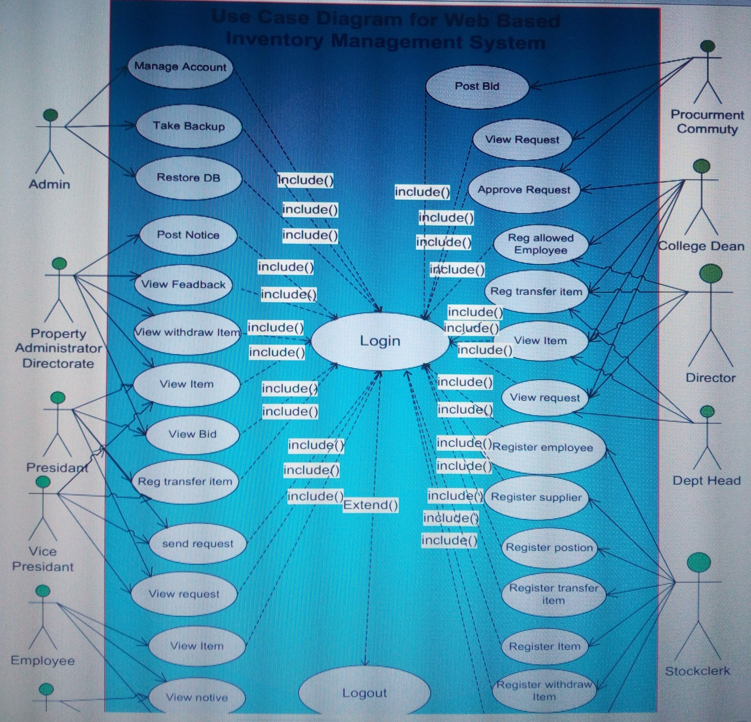
Figure 1 use case diagram

2.4.4 Use Case Description
- A use case is a methodology used in system analysis to identify, clarify, and organize system requirements. The use case is made up of a set of possible sequences of interactions between systems and users in a particular environment and related to a particular goal.

Table 2. Login Use Case Description
Use case name | Login
ID | Uc1
Description | To authenticate the user
Actor | Admin, Property Administration Directorate, stock clerk,  collage dean, Department head, Employee. Director,  president. Vice president. procurement commute
Pre condition | All actor must have an account
Post condition | Actor action  1. User opens the web page.  2. Select Login link.  4. Enter username and password.  5. User clicks on Login button. | System response  3. Login form  displayed  6. Validate data entry  7. User’s homepage displayed.  8. Use case end.
Basic course of Action
Alternative Course of Action | 6.The system returns the login form to resubmit valid data  if wrong user name and password submit[ACA]

2.4.5 Sequence Diagram
- A UML Sequence diagram showing the sequence of interactions among objects and used to represent or model the flow of messages, events and actions between the objects or components of inventory Management System. Sequence Diagrams are also used primarily to design, document and validate the architecture and interfaces of the system by describing the sequence of actions that need to be performed to complete a task or scenario.

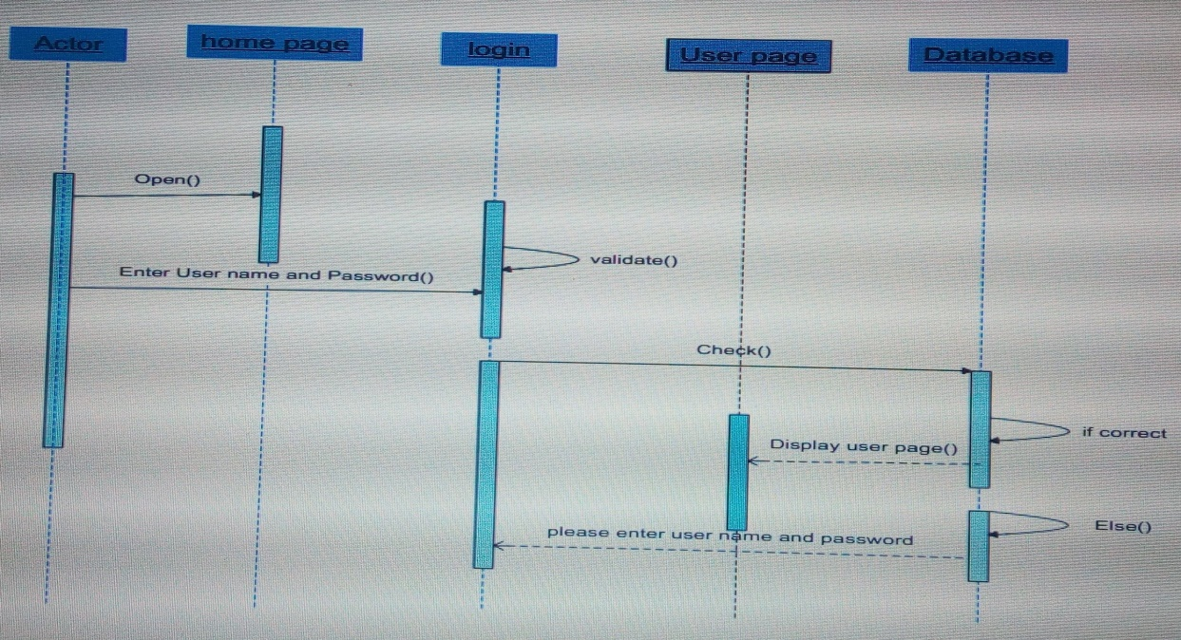

Figure 2 Sequence diagram for login
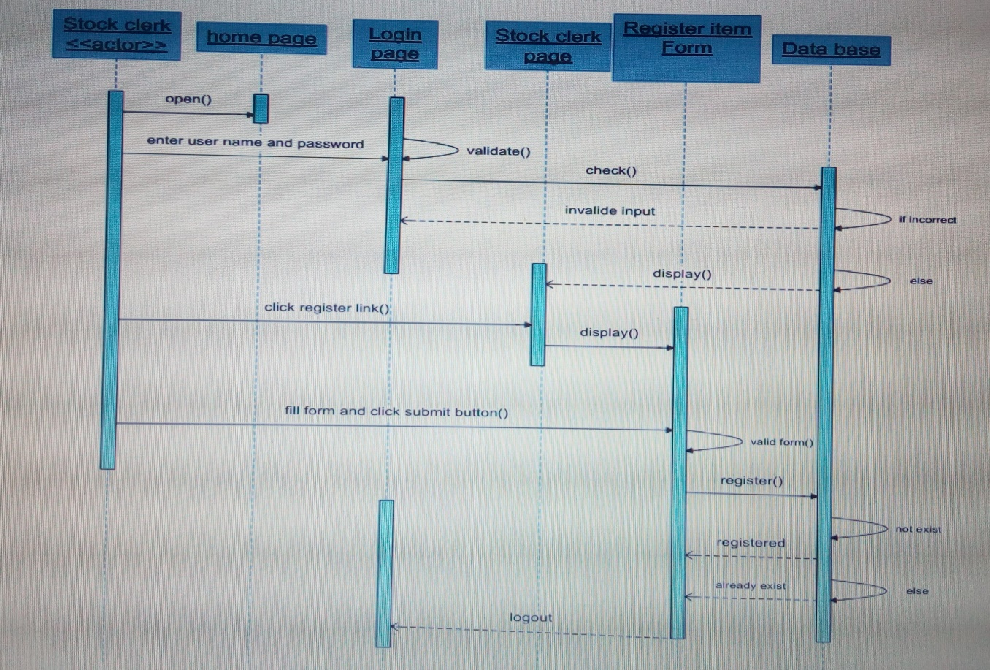

Figure 3 sequence diagram for register item

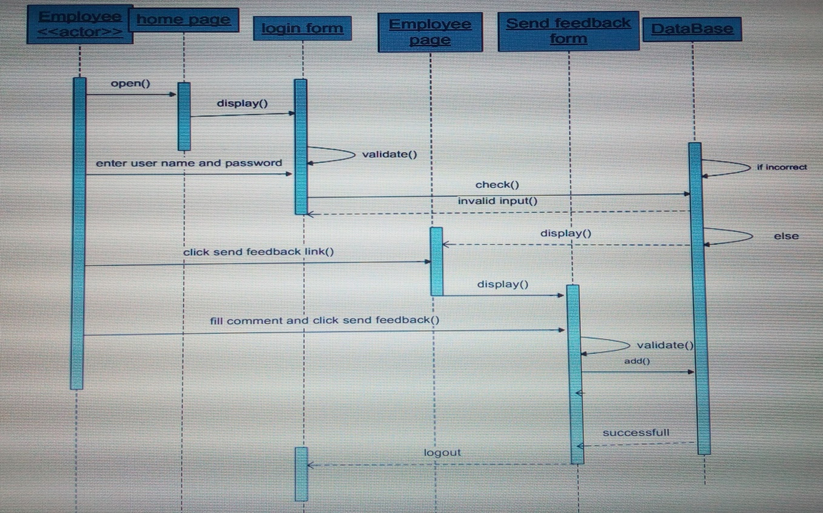

Figure 4 sequence diagram for send feedback
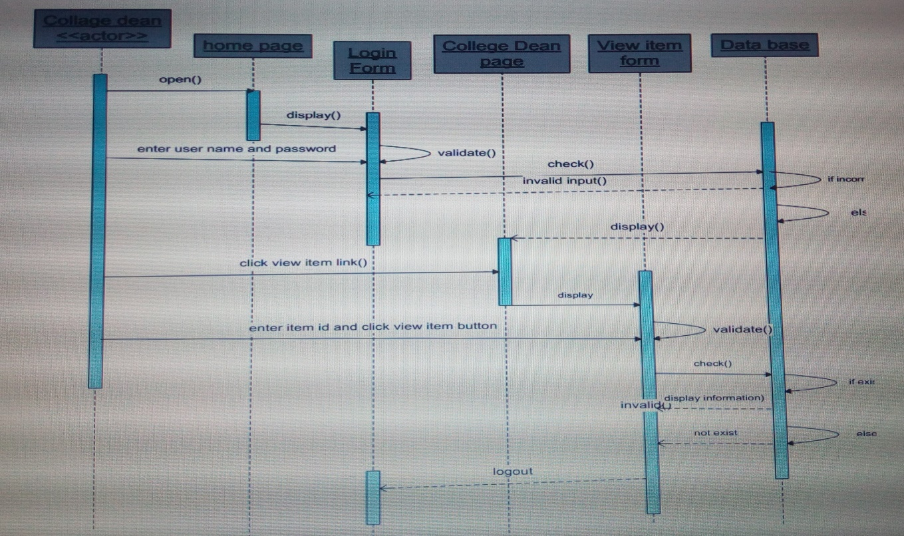

Figure 5. sequence diagram for view item

2.4.6 Activity Diagram
- Activity diagrams provide a way to model the workflow of a business process. Different tools such as decisions, start states, end states, are used on the activity diagram. Activity diagram is basically a flow chart to represent the flow form one activity to another activity.

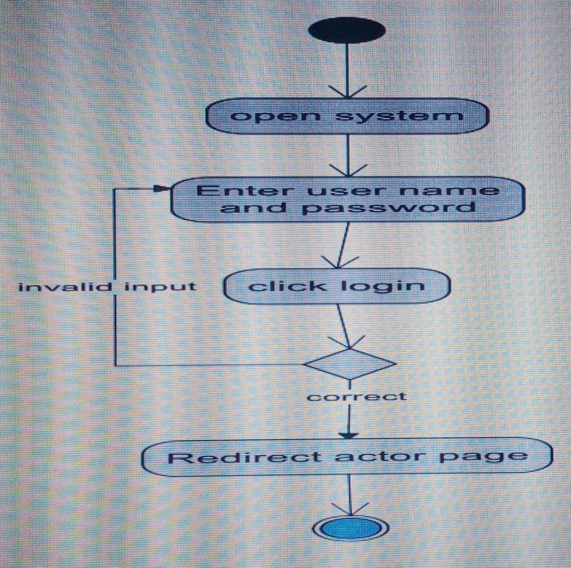

Figure 6. Activity diagram for logins

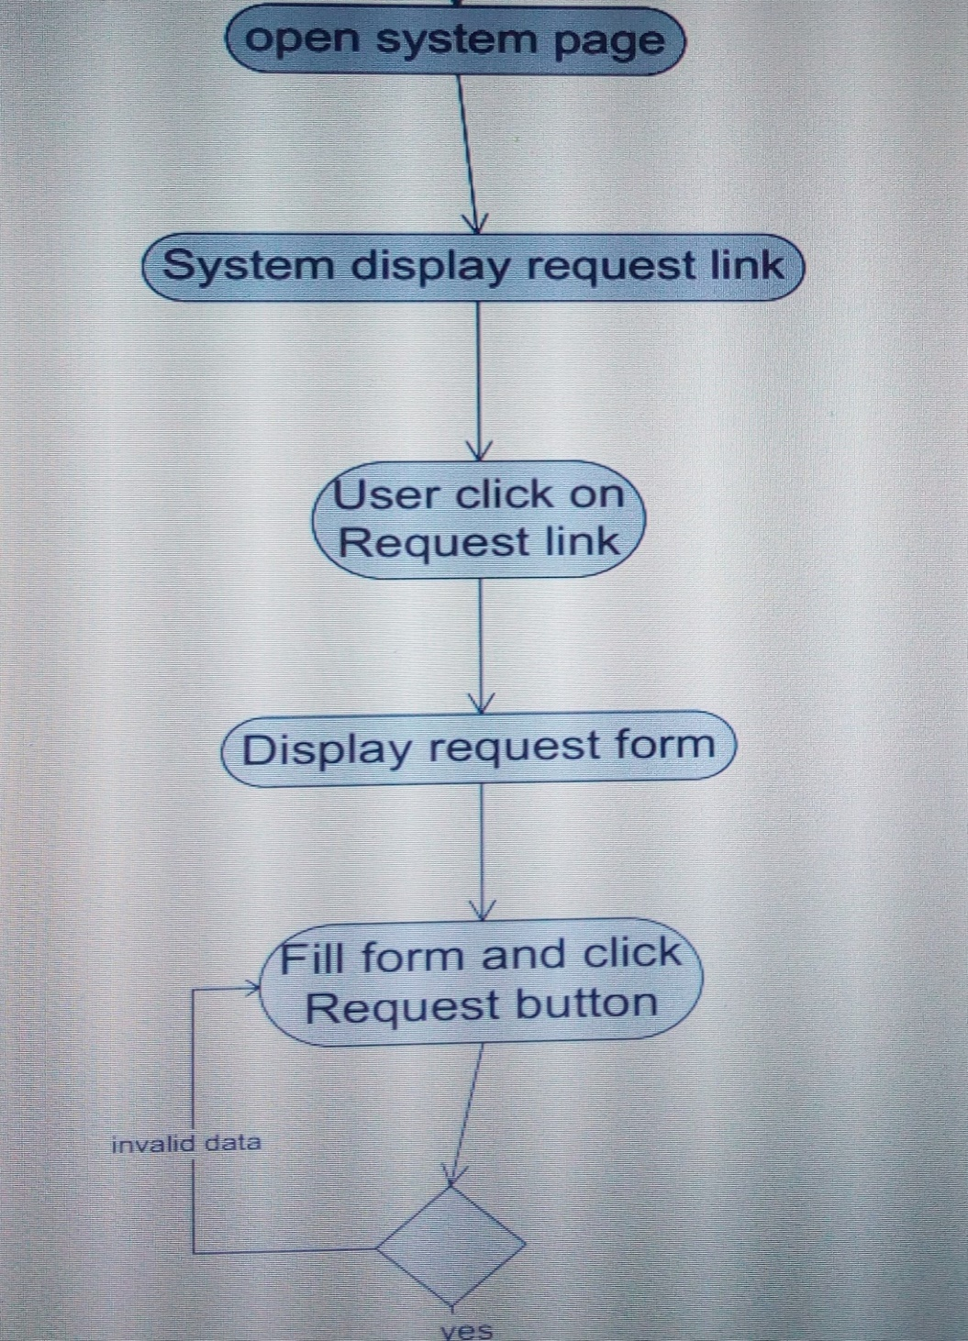

Figure 7Activity diagram for send request

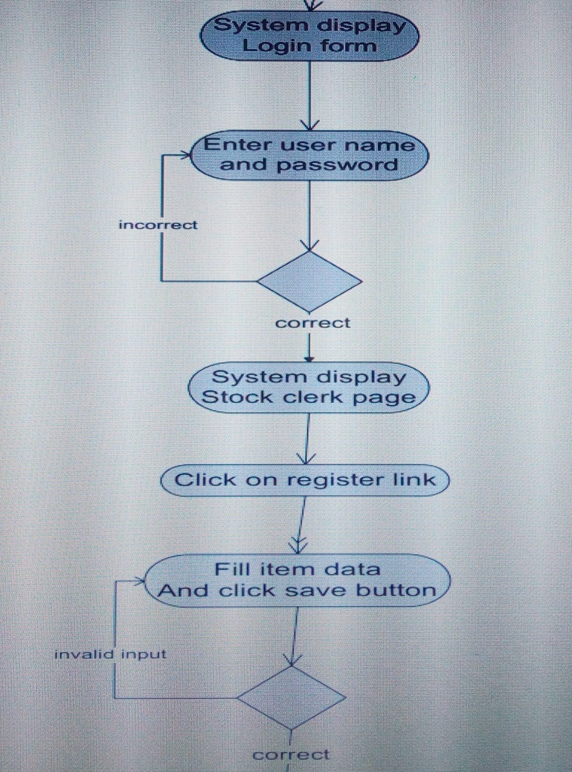

Figure 8Activity diagram for register item

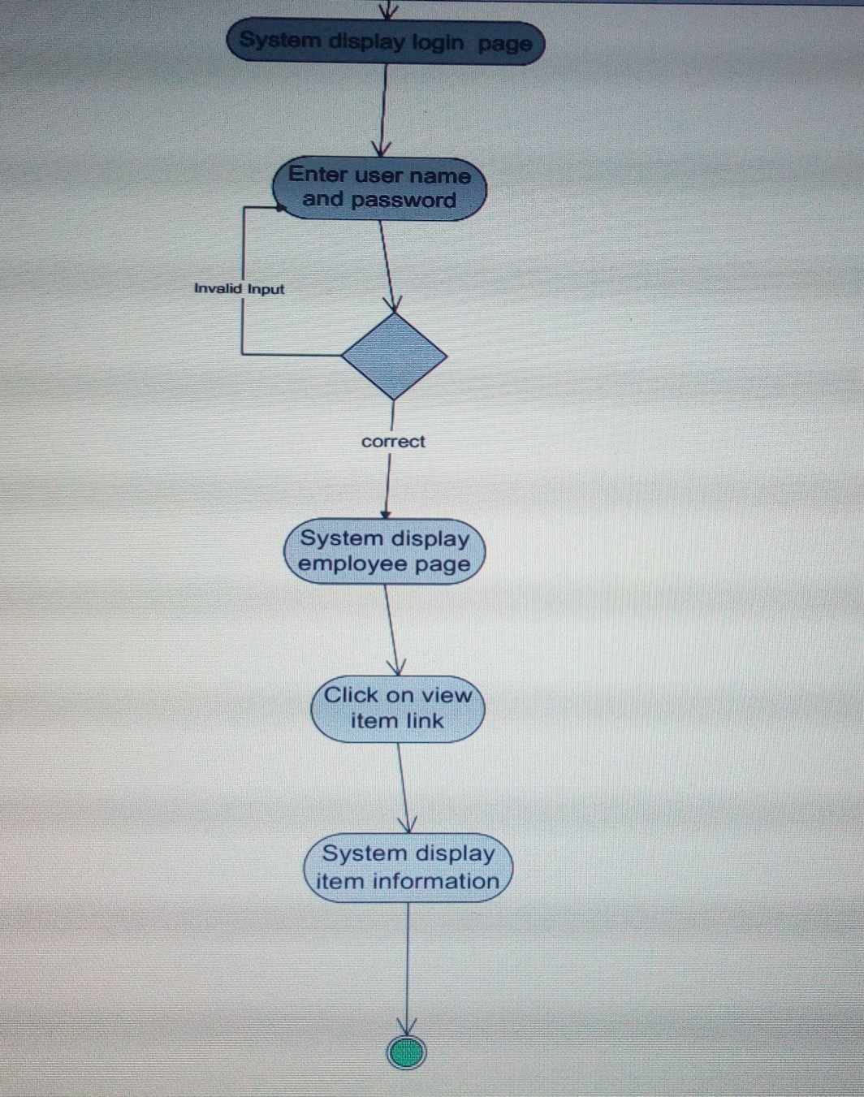

Figure 9 Activity diagram for view item

2.4.7 Analysis Class Diagram
- A class diagram is a diagram that describes the structure of a system by showing the systems Classes, their attributes, operations (or methods) and the relationships among objects Class Diagrams can also be used for data modeling. Class diagram has three components. The top Component contains the name of the class. The middle components contain the attributes of the class. The bottom component contains the operations the class can execute.

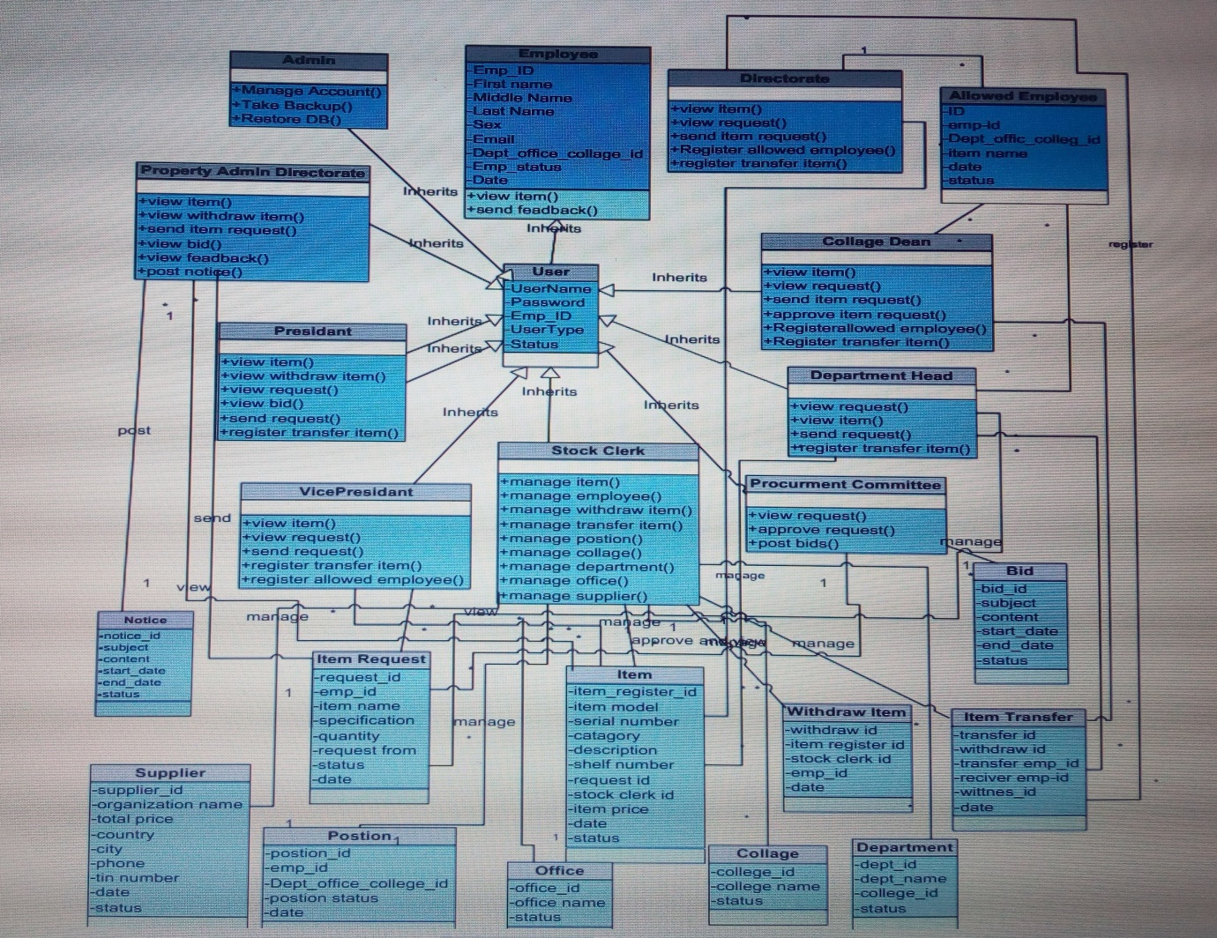

Figure 10 Analysis Class Diagram

CHAPTER THREE

3. Conclusion and Recommendation
3.1 Conclusion
- An effort has been made to study Web Based Inventory management system as partial fulfillment in Information technology. In order to solve or reduce different problems of the existed system that we tried to develop web based system. We believe that different tools and techniques has helped us a lot in capturing real user requirements and model the right system for the users for their day to day activities.
- Generally, the project is aimed at developing a Web Based Inventory management system. The system allows employee to perform tasks in an easy way.
3.2 Recommendation
- Nowadays, the world is highly becoming a competitive world in technology. So, Organizations should have to divert their attention on using the recent technology to facilitate their work properly. This can be real if they are able to use recent information technology (IT) to successfully achieve their objective.
- Generally, since technology is mandatory to help or accomplish all tasks qualitatively and quantitatively we recommend to the organization to automated the whole system as much as possible to fasten their work and to become enough competent to other organizations.
3.3 Future Enhancement
- The system will prepare well organized report
- The system will be developed by using android in a way to support mobile users.
- The system will be including other language like Amharic language
- The system will be including integrated system like human resource management system

Summary
- This Project Report dealt with the Easy and advanced way of inventory management system which regarding with contemporary globalization development. To enhance and make flexible the institution inventory management system within so many advantages such as keeping regularly different item and mage time which is by implementing major network and advanced software program with security technology. a day to day development of global technology are bring impact on different organization and university related with work activity and giving advanced and efficient services. In case of these more advanced and technological inventory management systems are applicable to use these service for more and effective item management activity.

Appendix
Activity Diagram:- diagram that describes procedural logic, business process and work flow supporting parallelism.
Actor:- a role that a user takes when invoking a use case. Also see actor modeling. Class the primary declarative construct of Object-oriented Programming; a cohesive unit of Attributes and Operations; a compile-time template for an Object
Class Diagram:- type of static structure diagram that describes the structure of a system by showing the system's classes, their attributes, and the relationships between the classes.
Sequence Diagram:- describes the Messages sent between a numbers of participating.

Reference
(1) https://www.modelio.org/tutorials/how-to-create-uml-use-case-diagram.html
(2)http://docs.embarcadero.com/products/rad_studio/delphiAndcpp2009/HelpUpdate2/EN/html/devcommon/uml15usecasediagramdefinitionexample_xml.html
(3) https://www.useoftechnology.com/technology-today-tomorrow/
(4) http://www.agilemodeling.com/style/classDiagram.htm
(5) https://www.tutorialspoint.com/uml/uml_deployment_diagram.htm
(6) https://en.wikipedia.org/wiki/User_interface_design
(7) http://www.etu.edu.et

